10.1-inch Professional Rugged GNSS RTK Tablet (Android 13)
Centimeter level positioning accuracy | 1408 channel full constellation tracking | 10000mAh long-lasting battery life
Product Overview
This 10.1-inch reinforced tablet is a top of the line mobile terminal designed specifically for high-precision surveying, geographic information systems (GIS), precision agriculture, and geological exploration. It perfectly integrates the smooth interaction of consumer grade tablets with professional grade RTK positioning technology, aiming to provide centimeter level real-time positioning capability in complex outdoor environments.
The device is equipped with a high-performance MT6789 eight core processor (with a maximum frequency of 2.2GHz) and the latest Android 16 operating system, which can smoothly run various complex professional surveying software. Its built-in high-performance RTK module has 1408 channels and fully supports GPS, Beidou, Galileo, and GLONASS constellation tracking. In RTK mode, it can achieve a horizontal positioning accuracy of 2.5cm. Equipped with a 10000mAh large capacity battery and 30W PD fast charging technology, it ensures the power continuity of long-distance field operations.
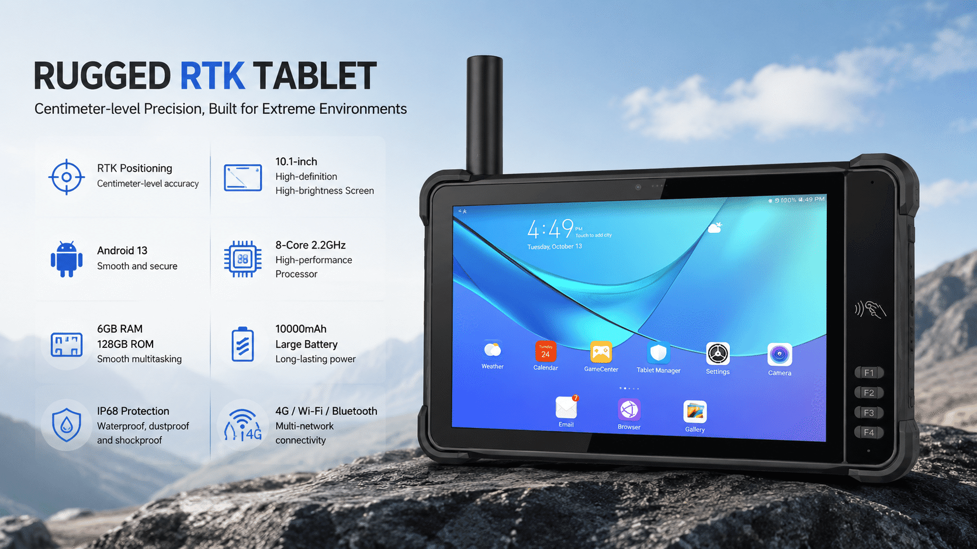
Key Highlights
Centimeter level high-precision positioning:
Multi constellation tracking: Built in 1408 channel GNSS chip, supporting GPS (L1C/A, L2C, L5), BDS (B1, B2, B2a, B31), Galileo (E1, E5a), and GLONASS (L1, L2).
Rapid convergence: RTK initialization time<10 seconds, providing high-precision horizontal positioning of 1.5cm+1ppm.
Professional interface: The top of the body is equipped with a dedicated RTK antenna interface, which can be connected to an external measurement antenna to obtain better signals.
Excellent processing performance:
Equipped with a 6nm MT6789 processor, it comes standard with 6GB RAM and 128GB ROM (up to 8GB+256GB optional), and supports 512GB TF card expansion.
Whether dealing with large-scale base maps or running 3D models, it can respond quickly.
Long lasting battery life and fast charging:
Equipped with a 10000mAh ultra large capacity polymer lithium battery, the working time exceeds 10 hours.
Supports 30W PD fast charging, which can be fully charged in just 2-3 hours, significantly reducing waiting time.
Durable and sturdy industrial design:
Protection level: It has IP67 dust and water protection capability, and is not afraid of rain, mud, and dust.
Drop resistance: Passed multiple 1-meter cement floor drop tests.
Interaction optimization: 10.1-inch high brightness screen supports glove touch; There are 4 custom function keys on the front for engineers to quickly launch measurement applications.
Comprehensive connection and collection:
Supports 4G full network, dual band WiFi, Bluetooth 5.0 to ensure real-time data transmission.
Equipped with a 1600W pixel rear high-definition camera (supporting autofocus and flash) for easy on-site image retention.
Typical Application Scenarios (Ideal Applications)
Land Surveying&Mapping
Precision Agriculture Navigation
Digital Construction and Utility Inspection
GIS Data Acquisition
• Geological Survey and Disaster Monitoring
Technical Specifications Summary
• System/chip: Android 13/MT6789 8-core 2.2GHz
Screen: 10.1 inches (800x1280 or 1200x1920) with support for multi-point/glove touch
• Positioning accuracy: RTK 1.5cm (H)/GNSS 2.5m CEP
• Battery/Charging: 10000mAh/30W PD Fast Charge
• Protection level: IP67/1m Drop Resistance
• Size/Weight: 290.6 * 182.5 * 18.5mm/980g

Basic Information
processor | MT6789 (2 Arm) ® Cortex-A76 core, operating frequency of 2.2GHz, 6 Arm ® Cortex-A55 core, operating at a frequency of 2.0GHz
operating system | Android 16
RAM+ROM | 8G+128G Optional: 8G+256G
Expand memory | Micro SD card, supports up to 1TB
display | 10.1 inches, resolution: 800 * 1280 800nits.  Optional: 10.1-inch/1920 * 1200/IPS 600nits/Supports glove mode/wet hand mode
Touch Screen | Capacitive screen: supports multi touch, glove touch
Rear camera | Rear 1600W pixels support autofocus and flash
Front Camera | Front 500W pixel (optional)
audio | Main MIC*1, Noise Reduction and Echo Cancellation*1
audio | Speaker (4W) * 1
prompt | 2 RGB lights
prompt | Vibrating motors
keystroke | Left: Volume +-, Scan key  Right side: Power on button  Front: 4 custom function keys
External interfaces | Left: TYPC-A  Right side: SIM card holder + TF card holder, TYPC-C  Top: RTK antenna interface
Booths | Nano SIM card * 2&Nano SIM card x 1+T_FLASH * 1
sensor | Light sensing+distance, gravity sensor+6-axis gyroscope  Optional: Compass, air pressure sensor
battery | 10000 mAh polymer lithium battery,  Standby time> 350 hours  Working time> 10 hours (depending on the usage environment)
Charging method | Type-C 30W PD fast charging  The charging time is 2-3 hours, using the standard power adapter and data cable
Communication Transmission
WLAN function | Dual-band 2.4GHZ/5Ghz, support IEEE 802 a/b/g/n/ac protocol
Bluetooth | Supports Bluetooth 2.1+EDR/3.0+HS/4.1+HS+5.0
GNSS | Supports GPS, Galileo, Glonass, Beidou
Wireless WAN (Data Service) | GSM/GPRS/EDGE/CDMA/UMTS/HSPA/HSPA+/WCDMA/TD-SCDMA/TDD-LTE/FDD-LTE
Wireless WAN (Network Frequency) | 2G:GSM( B2/B3/B5/B8)  3G:WCDMA( B1/B2/B5/B8)  4G:FDD:B1/B2/B3/B5/B7/B8/B20/B25/B26/B28  TDD:B34/B38/B39/B40/B41
RTK
parameter | performance indicators
GNSS tracking channel | 1408
GNSS receiving frequency point | GPS/QZSS: L1C/A, L2C, L5
GNSS receiving frequency point | BDS: B1, B2, B2a, B31.
GNSS receiving frequency point | Galileo: E1. E5a
GNSS receiving frequency point | GLONASS: L1,L2.
Data update rate | PVT maximum value 10Hz
Data update rate | RTK maximum value 5Hz
positioning accuracy | GNSS 2.5m CEP
positioning accuracy | D-GNSS <1.0m CEP
positioning accuracy | RTK 1.5cm+ 1ppm(H)
Speed and time accuracy | GNSS 0.1m/s CEP
Speed and time accuracy | 1PPS 20ns
Time of first positioning (TTFF) | Hot start for 2 seconds
Time of first positioning (TTFF) | Cold start for 24 seconds
Time of first positioning (TTFF) | RTK convergence time<10s
sensitivity | Cold start -148dBm
sensitivity | Hot start -158dBm
sensitivity | Re capture -160dBm
sensitivity | Tracking&Navigation -1 62 dBm
Application limits | Speed 515 meters per second
Application limits | Height 18000 meters
Optional functions
NFC | Operating frequency: 13.56MHz  agreement :ISO14443A/B, ISO15693, NFC-IP1, NFC-IP2  Tag standard: M1 card(S50, S70), CPU card, NFC tag, etc  Reading and writing distance: 1-3cm
Environmental parameters
Operating temperature | -20℃~55℃  *For safety reasons, do not charge in a low temperature environment
Storage temperature | -40°C~70°C (without battery)
humidity | 0~95% (no condensation)
Drop Specs | The 1-meter concrete floor fell many times
Ingress protection | IP67
Electrostatic discharge | ±15KV (air discharge), ±8KV (contact discharge)
Development support
Development language | Java
Develop APIs | Android standard interface
Structural parameters
Dimensions (mm). | 290.6*182.5*18.5mm
Weight as standard | 980g
Equipment accessories
Standard accessories | Adapters, data cables, protective films

